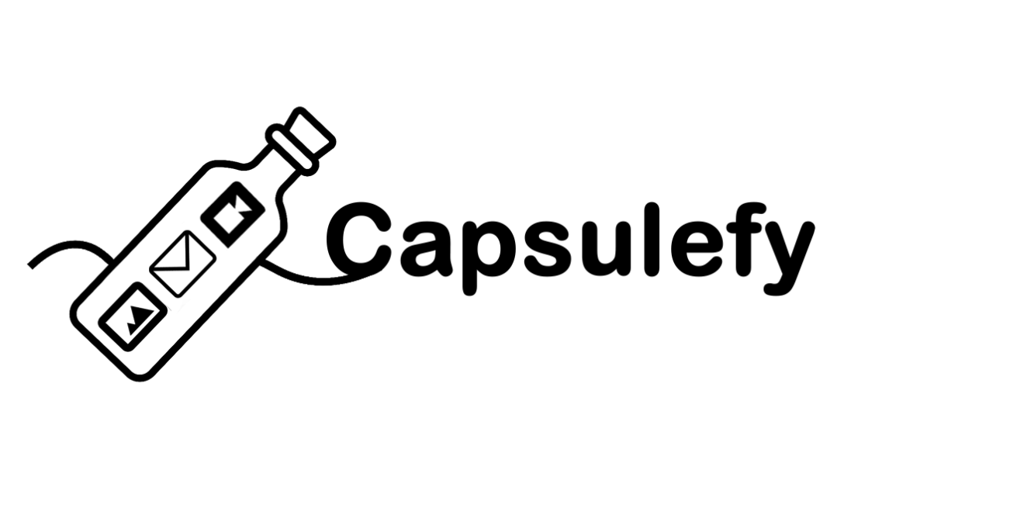

BUSINESS PLAN DOCUMENTATION

Group 15

Email: [capsulefy.communications@gmail.com](mailto:capsulefy.communications@gmail.com)

Website: <https://capsulefy.herokuapp.com>

GitHub: <https://github.com/pabreblob/capsulefy/releases> (Release 6)

Cantón Fernández, Adrián

Carpio Camacho, Daniel

Fresno Aranda, Rafael

Rebollo Lobo, Pablo

Rodríguez Regidor, Juan

Index

Introduction 1

Business Idea 1

Development team 2

Competitors analysis 2

SWOT analysis 4

Strengths 4

Weaknesses 5

Opportunities 5

Threats 5

Return of investment analysis 7

Investment analysis 10

Items produced as a result of this deliverable 11

# Introduction

The aim of this document is to provide information about the preparations that have been made in order to launch our product, as well as the results obtained from that. A quick overview of the business idea, team roles and costs is also provided, but for more extensive information about this topic please refer to the “Devising a project” document. For more information about the result of our development sprints, please refer to our sprint documents. The information about the tasks that were carried out during our project launch week is available at the “Project launch documentation” file.

# Business Idea

Capsulefy is an online time capsule that allows users to store their memories and share them in the future. Users will be able to create a time capsule, attach a message to it, load files such as videos or images into it and set a date when they want the capsule to be released.

The capsules can also be connected to the user’s social networks so that a message is automatically posted when the capsule is published. Users will also be able to select a list of emails that will receive a notification message.

One of the main selling points of our product is allowing people to leave a message behind in case they pass away. For this reason, we will offer a dead-man switch option that once activated, will automatically release the capsule regardless of its publication date if the user hasn’t refreshed the counter after a certain period of time.

Our capsules also offer extra features such as the possibility of splitting them into different modules, each of them with a different release date, or making them private so that they won’t appear when listing the capsules.

We will be offering two different types of capsules: Free and premium capsules.

Each registered user will be able to create free capsules and upload files to them up to a maximum of 20mb in total. These capsules can be scheduled up to one year in the future and will be deleted 6 months after their release. These capsules can’t be made private, split into modules or have a dead-man switch set up

Premium and modular capsules will cost 11.99 € each, can store up to 500mb of files and will not have a limit on how far into the future they can be scheduled, nor will they disappear after being released.

# Development team

Our team is composed by five members, each one with different roles and responsibilities:

* Pablo Rebollo Lobo. His roles are project manager and backend developer. His main technological competencies are Spring, Django and PHP.
* Adrián Cantón Fernández, whose roles are business manager and full-stack developer. His main technological competencies are Django, Java and Bootstrap.
* Daniel Carpio Camacho, analyst and frontend developer. His main technological competencies are Django, JavaScript and Bootstrap.
* Juan Rodríguez Regidor, whose roles are requirements engineer and backend developer. His competencies are Django, Python and Bootstrap.
* Rafael Fresno Aranda. His role is backend developer and will also be in charge of the interaction of our product with other applications. His main technological competencies are Node.js, Django and PHP.

Our commitment as a team is to develop our business idea in order to create a minimum viable product in a good enough state so that it can receive appropriate feedback to decide whether or not release the full version to the market and apply that feedback to improve our product.

To reach this goal, we are compromised to meet the deadlines, listen to the feedback and cooperate within the team so that we can provide a product that meets our quality standards.

# Competitors analysis

We did an initial market research in order to determine which existing online services our product will be competing with, which are their main features and what makes our product different from them. We found 4 other similar services. The results of comparing them to our product are the following:

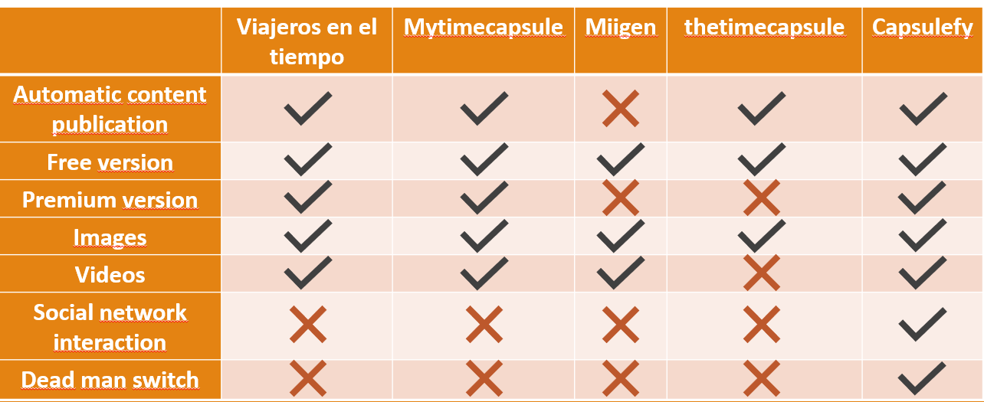

Figure 1: Competitors analysis table

We reached the conclusion that we are treading into an already existing market, but an undeveloped one, where we can offer features that makes us distinct from our competitors, such as the interaction with social networks and the publication of content in case the user has not logged in for a very long time.

There are other indirect competitors, such as official last wills or more traditional methods of sharing memories like photo albums, but they won’t be able to offer the possibility of quickly sharing their contents online.

The innovation of our app are these two features no other application similar to us provides: The dead man switch and social network interaction. While the development of these features does not imply that we are innovating from a technological viewpoint, since we will be using already existing technologies (OAuth, API calls…), the way we are incorporating them into our business model is something new that has not been tried by our more direct competitors. Thanks to these features, our service is highly customizable so that every user can tailor their time capsules to their needs.

Besides, we also analyzed another possible competitor, this one more focused on digital legacy: Milegadodigital.com. We don’t consider it a direct competitor, as it is more focused on digital last wills, where there are no free options for their services , which are based on content publication and credentials management and inheritance which are offered after the family has provided the company with the defunction certificate of the user.

Our services are oriented to the publication of any kind of content, not only restricted to those related to the legacy a person may want to leave behind, for example, a message a parent may want to leave to his child when he grows up or a birthday message. We also provide a free option for our users, which allows them to test the application so they can decide whether or not they are interested on our paid services. Capsules can also be shared through social media and email. Our capsules can be used as a mean of leaving a digital legacy, just as Milegadodigital.com, but they do not require any certificate from the family, as we provide the option to publish a user capsules if he has not interacted with our application for a long time.

All in all, we offer a more customizable service with more applications that just digital legacy, which means we have a bigger audience than Milegadodigital.com

In order to make sure if our pricing is appropriate, we made a survey about it, and 40% of the people asked said that they would be willing to pay at least 20€ for what we offer. This means that the initial planned price, 11.99€ for a premium capsule, is more than reasonable. However, in order to get a better grasp on the pricing of similar products, we looked up the prices of those applications similar to ours that offer a premium plan:

|  |  |  |  |
| --- | --- | --- | --- |
| Product | Mytimecapsule | Milegadodigital | Capsulefy |
| Price | 8.97€ | 79€ | 11.99€ |
| Features | 100mb of storage | Online last will basic plan | 500mb of storage, deadman switch |

We have come to the conclusion that while our product is a bit more expensive than Mytimecapsule, we also offer more options and more storage, while Milegadodigital, as suspected, is focused on a different type of market, and therefore, the price of their services is completely different from ours.

# SWOT analysis

Now that our application is finished, we clearly now what are its strong and weak points, which allows us to make a more detailed SWOT analysis than the one that was made while devising the project.

## Strengths

• None of our competitors has capsules that will automatically be released in case of decease.

• Our application is much more complete and with more features than the already existing options.

• Highly customizable capsules.

• Free version available in which may attract potential customers after trying it.

• Our application has social media integration, while our competitors don’t.

• We offer more storage size than other options for a similar price.

## Weaknesses

• We have just arrived to this market niche and need to make ourselves known.

• Some people may find hard to understand some features of our website, like the deadman switch.

• We only accept Paypal as payment method, this means we may lose customer who have no Paypal account

## Opportunities

• None of the existing applications has a total monopoly over the market, this means we can earn ourselves a position among the existing alternative and try to reach the top.

• There is the possibility of cooperating with insurance companies. The idea is to strike a deal with them so they can offer our services to their clients who acquire a life insurance. The users will be able to create a premium capsule in our site and the insurance companies will be charged for it. In order to make this deal more attractive, we may give these companies a special pricing, and their clients will have no date of expiration in their capsules.

• We can use special days, like Christmas, to announce our application via discount and referrals campaigns.

• High number of target users due to the multiple purposes that our capsules may have.

## Threats

• One of our competitors may improve their application and gain a bigger share of the market. A new competitor may also appear with similar key features as us.

• Lack of trust from our possible customers, mainly due to two reasons: Not understanding what our product is about and not having guarantees that if our business closes down, the capsules they have paid for won’t disappear.

• In order to mitigate these threats, we will need to invest in advertising so that people will see us as the best option when it comes to time capsules and will be well informed about what our business is about. On the other hand, we must find a way to assure our potential clients that they will get what they paid for regardless to what happens to our business, and worst-case scenario, assuring that they will get a full refund in case our servers shut down.

• Not reaching the limit of target users needed to get enough income to maintain servers and developers.

* People who already have written a last will may find our product unnecessary.

# Threat mitigation

We have come up with some ideas in order to deal with the threats previously mentioned in our SWOT analysis:

* For competitors who may improve their product or create a new one better than what we currently have, out idea is to keep improving our application and adding more features, such as integration with more social networks (Facebook, Instagram, LinkedIn) while maintaining our pricing. This way, we can make sure our product remains the most attractive one out of all the similar options in the market.
* Lack of trust from our potential customers: Firstly, we will need to invest in advertising so that people will see us as the best option when it comes to time capsules and will be well informed about what our business is about. On the other hand, we must find a way to assure our potential clients that they will get what they paid for regardless to what happens to our business, and worst-case scenario, assuring that they will get a full refund in case our servers shut down. In order to get people to know about us and spread the word, we will have special promotions and giveaways, specially during our first months. This way, people will be using our services and they will see that we are trustworthy.
* If the number of users is way lower than expected, we will need to try and lower our expenses while improving our marketing to reach a bigger audience. The way we can accomplish this is by focusing on the channels that are obtaining the best results and stop investing on those which are doing badly. A low rate of customers might also mean that our product is not as good as expected, and therefore, we will research the market to come up with improvements.
* As for the possibility of people not being interested in our application because they already have a last will written, one measure we can take is not putting the focus of our application only as a way of leaving a legacy behind, and trying to make it more appealing to a wider audience. Also, during our marketing campaign we should focus on its social components and the ability to share your capsules with any person you have met online, something that is way more complicated to do with a written last will.

# Return of investment analysis

Up to this point, the expenses of our project are the following:

|  |  |
| --- | --- |
| Project duration | 14 weeks |
| Total spent in salaries | 14,390 € |
| Equipment | 325€ |
| Hosting (1 year) | 669€ |
| Advertising( 6 months) | 3,060€ |
| First year maintenance | 15,000€ |
| Risk prevention fund | 2,724€ |
| Total costs | 35,168€ |

Because initially it has been considered costs not only relate with development, but also with maintenance, hosting, and advertisement, we know that these will be all our expenses during our first 6 months. The price that has been decided for our premium capsules is 11.99€, because a survey made revealed that 40% of the people asked would be willing to pay at least 20€, which gives us an idea that 11.99€ is not too steep of a price. Taking taxes into account, this means that we would be making 9.5€ each time we sell a capsule.

For our first month, we expect to sell between 100-200 capsules. Because during our first week these capsules will be free of charge, we will only get revenue for 75% of those sales. Assuming 200 sales, we expect to get income from 150 capsules. During the three remaining weeks, premium capsules will have a 20% discount. This means that, if we were to make ~1425 € from those 150 at full price, with the discount we would have a revenue of 1140€ during the first month.

We expect to sell around 700 capsules during our first 6 months, which means that we would be selling at full price ~500 capsules, which means an income of 4750 € approx., which adds up with the discounted capsules for 5900€ during our first 6 months.

For the following 6 months we need to factor in new costs for our advertising campaign. We will invest 3060€ just like in the first 6 months, the reason being that we do not want to increase our spendings until reaching the point were our costs and profits break even, and because we will have information about which media has been the most and least successful when advertising, we can transfer funds from our worse performing source to the one who performs better, meaning an increase on the effect of our advertising without having to spend extra money. Hosting and maintenance were already covered for the first year, so there is no need to spend more on these. This gives us a total spending of 38K euros for the first year.

For the second half of the year, we expect to have become more well known, which means a substantial increase in sales. We will assume 1400 sales during these 6 months, which means a profit of 13300€.

Taking all these earnings and expenses into account, the balance for our first year would be the following:

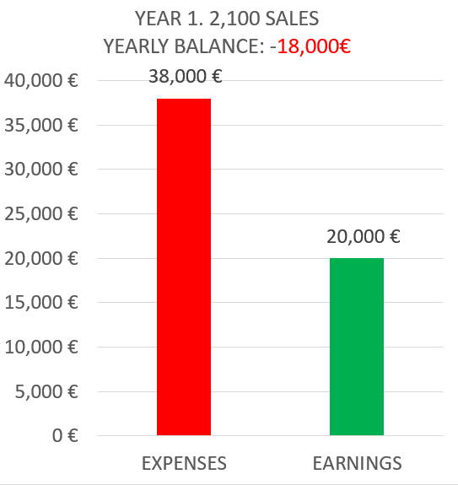

During the second year, we expect to keep selling our capsules at full price with some exception, such as discount campaigns. For this reason, we will assume that our total revenue will be about 90% of the price of the capsules sold. We need to take into account the costs of advertising, hosting and customer support, which will be the same as the previous year, which adds up to a total of 21,800 € to spend. On the other hand, we expect to double the sales of the first year, as we expect to have gained more traction in the market.

These are the estimations for our second year:

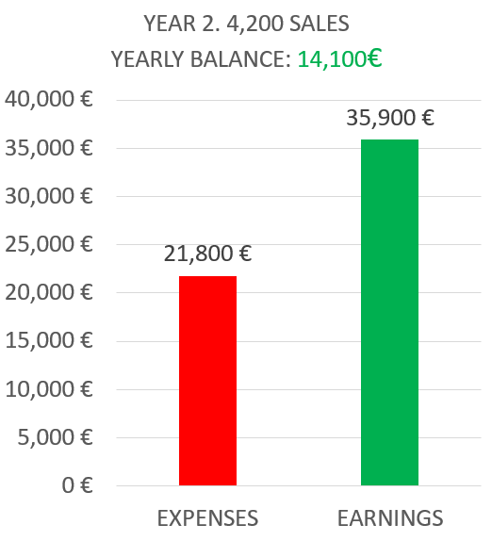

As for our third year, we expect our situation to change. Because at this point we have made back almost all the money invested, we will begin a more aggressive expansion plan. Our marketing department budget will be doubled, and in order to give service to a bigger amount of users, our maintenance costs will increase by 50%. With this strategy, we hope to reach 10K sales during this year, which will give us the following results:

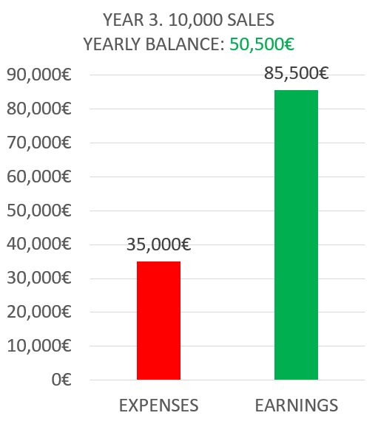

The progression of the profit that we expect to make along these first three years is the following:

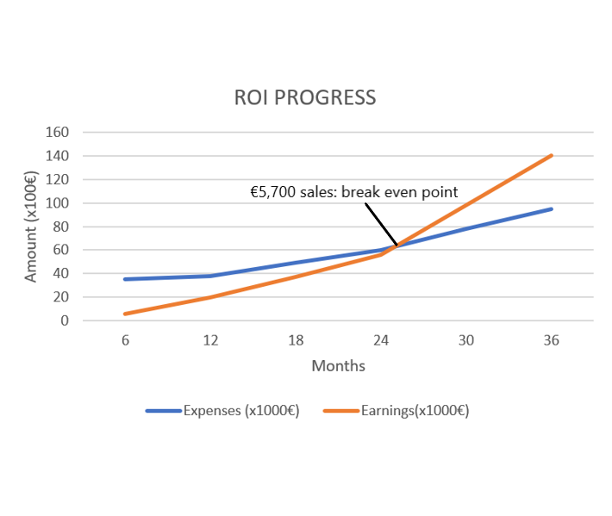

We can observe that we will recover the investment made by the beginning of the third year. This is the reason why it was decided to start an expansion campaign, with more expenses.

The way to read this graph is the following: Blue line indicate the expenses, starts at 35K € and that we have personally invested in the project. Afterwards, any expenses up to the end of the 3rd year is afforded thanks to our investors. The orange line indicates the earnings we are getting from our capsules alone, and we can observe how from the beginning of the 3rd year (month 25) onwards we are earning more than the expenses that are being made. This marks the point of balance from where we start making profit.

# Investment analysis

At this point in time, the value of our product and the hours of work dedicated to its development is 35,000 €. This include the value of the hours invested and the expenses that were initially accounted for, such as customer support costs. These costs will be taken care of by the team behind this application, which means that we will not perceive any monetary compensation for the hours invested and that we will invest the 20K euros remaining of our initial budget. This leaves us with 55K € for which we need to find investors.

Our compromise with our investors is giving them back what they have invested +10% of the amount invested, which leaves us with nearly 60K euros to return. According to our estimations, we will be able to reach this amount by the end of the third year. Afterwards, investors will get a percentage of the business revenue based on the percentage of the cost of our product they have invested in, this means that by investing they will have a share of our company. We are estimating that we need a total of 90K € for our application to succeed and our initial investment is of 20K € + 15K € of our salaries, we hold 40% of the shares of the company, which will be equally distributed among our five members, meaning each one of us will hold a 8% of the company shares. The 60% left is distributed between the investors that will pay for the 55K € left and they will get a percentage of these shares depending on the amount the invest. We will also make clear in what are we investing this money: Mainly customer support, advertisement, hosting and storage during the first three years.

As for the conditions we will impose to these investors, we will only ask that their invested amount is at least 500 euros per person.

In order to afford the initial 35,000€, we will ask a loan of 20K, as the other 15K can come out of our pockets so that we don’t need to pay unnecessary interest rates. If we do not manage to get enough investor to cover all our spendings, we will either ask for another loan or reduce the budget for our third year.

# Postmortem analysis

We had a final meeting in order to review our project and we reached some conclusions:

* Integrating our capsules with Facebook would have been really interesting, as it was one thing some pilot users proposed as an improvement. The hardships we faced when trying to integrate it could have been dealt with if we had started working on this task earlier.
* At the beginning, our business idea was not clear and the application underwent several changes at early stages of development. If we were to redo it, we would have saved a lot of the time we spent discussing which features would be implemented.
* There were some compatibility issues between libraries our developers were using, but thankfully these conflicts were solved.
* On a more positive note, we met all the deadlines and all our deliverables were satisfactory. This leads us to think we have done a good work overall during the development of this project.
* Our pilot users have also shown their satisfaction with our final product, as we tried lo listen to their feedback and apply it as much as possible.

# Items produced as a result of this deliverable

Final version of our application, deployed on <https://capsulefy.herokuapp.com>

Demo videos of our application, which can be found in our slides. The release of this sprint in GitHub can be found on <https://github.com/pabreblob/capsulefy/releases> (Release 6).

Knowledge database available at: <https://github.com/pabreblob/capsulefy/wiki>

All the documentation related to the development of this project.